

College of Computing and Informatics
Department of Information Science
Student Research Project Phase I
A Web-based Student Information Management for Haramaya University Non-Boarding School
[by]
S No | Student name | Id No
1 | Abenezer Aschalew | 0065/15
2 | Abdulahi Yesuf | 1968/14
3 | Addisu Gemeda | 2063/14
4 | Yosef Tiruha | 1090/15

Advisor Mr. Wabi J.

December 2025
Haramaya University, Ethiopia

Declaration
We, Abenezer Aschalew, Abdulahi Yesuf, Addisu Gemeda and Yosef Tiruha hereby confirm that the final project documentation submitted to the Department of Information Science, Haramaya University, is an honest and accurate representation of our work. We affirm that all the content is original and has been completed with dedication and integrity as part of our final project phase I at Haramaya University.

________________________ ___________________ _________________

Name of Advisor Signature Date

_________________________ ___________________ _________________

_________________________ ___________________ _________________

_________________________ ___________________ _________________

_________________________ ___________________ _________________

Name of student Signature Date

Acknowledgment
We begin by expressing our profound gratitude to the Almighty for the strength and guidance to complete this work. This project is the culmination of collective effort, and we are deeply indebted to those who supported us throughout the process. We would like to extend our sincere appreciation to our advisor, Mr. Wabi Jifara, for his invaluable expertise and consistent mentor ship. Additionally, we thank our classmates for their constructive feedback and suggestions, which were instrumental in refining this documentation. Finally, our thanks go to everyone who provided direct or indirect assistance in bringing this project to fruition.

Table of Contents
Declaration ii
Acknowledgment iii
List of Figures viii
List of Tables ix
Abbreviations x
Abstract xi
Chapter One 1
Introduction 1
1.1 Background of the Project and the Organization 1
1.2 Statement of the Problem 2
1.3 Objective of the Project 3
1.3.1 General Objective 3
1.3.2 Specific Objectives 3
1.4 Feasibility Study 3
1.4.1 Operational Feasibility 3
1.4.2 Technical Feasibility 4
1.4.3 Economic Feasibilty 4
1.4.4 Behavioral/Political Feasibility 5
1.4.4 Schedule Feasibility 5
1.5 Significance of the Project 6
1.6 Methodology of the Project 7
1.6.1 Data Source 7
1.6.2 Data Collection Methods 7
1.6.3. Fact Finding Techniques 8
1.6.4 Software Development Methodology 9
1.6.5 Development Tools 9
1.6.6 Testing Procedures 10
1.6.7 Implementation Plan 11
1.6.8 Scope of the System 11
1.6.9 Limitation of the System 12
1.6.10 Ethical Consideration of the Project 12
Chapter Two 13
Description of the Existing System 13
2.1 Overview of the Existing System 13
2.2 Players in the Current System 14
2.3 Business Rules 15
2.4 Main Functions to the Existing System 16
2.5 Bottlenecks of the Existing System (Using PIECES Framework) 18
2.5.1 Performance (Response Time) 18
2.6 Forms and other documents of the existing systems 18
2.7 Proposed solution for the new system that addresses problems of the existing system 19
2.8 Requirements of the Proposed System 20
2.6.1 Functional Requirements 20
2.6.2Non-Functional Requirements 20
Chapter Three 22
System Analysis 22
3.1 Introduction 22
3.1 System Requirement Specifications (SRS) 22
3.2.1. Use case Modelling 22
3.2.2 Use case documentation/description 23
3.2.3. Sequence diagram 27
3.2.4. Activity Diagram 28
3.2.6. User Interface Prototyping 30
3.2.7. Supplementary specifications 31
Data relating to students will remain confidential and inaccessible to the third party. Only the relevant information will be accessed by the users. The system will adhere to Data handling and privacy ethical standardsChapter Four 32
System Design 32
4.1 Introduction 32
4.2 Class Type Architecture 32
4.2.1 User Interface Layer 32
4.2.2 Process (Controller) Layer 33
4.2.3 Business (Domain) Layer 33
4.2.4 Persistent Layer 34
4.3 Class Modeling 35
4.4 State Chart Modeling 36
4.5 Collaboration Modeling/Diagram 38
4.6 Component Diagram 39
4.7 Deployment Diagram 40
4.8 Persistent Modeling 41
4.9 User Interface Design 45
4.9.1 Form Design 46
4.9.2 Report Design 46
4.9.3 Dialog and Interface Design 46
Chapter Five 47
Implementation and Testing 47
5.1 Introduction 47
5.2 Final Testing of The System 47
5.2.1 Unit Testing 48
5.2.2 System and Integration Testing 48
5.3 Hardware software acquisitions/specifications 48
5.4 User manual preparation 49
5.5 Training 50
5.6 Installation Process 51
5.7 Start-Up Strategy 51
Chapter Six 52
Conclusion and Recommendation 52
6.1 Conclusion 52
6.2 Recommedation 52
References 54

List of Figures
Figure 1 : Usecase Diagram 23
Figure 2 : Login Sequence Diagram 28
Figure 3 : Grade Submission Sequence Diagram 28
Figure 4 : Activity Diagram for Login 29
Figure 5 : Activity Diagram for Student Registration 29
Figure 6 : UI Prototyping 30
Figure 7 :Class Modeling 36
Figure 8 : State chart for Login 37
Figure 9 :State Chart for Registration and Updating Student Info 38
Figure 10 : Collaboration Diagram 39
Figure 11 : Component Diagram 40
Figure 12 : Deployment Diagram 41

List of Tables

Table 1 : Estimated Budget BreakDown 5
Table 2 : Time Schedule 6
Table 3 : Use Case Description 27
Table 4 : Persistent Design 45

Abbreviations
API: Application Programming Interface
ETB: Ethiopian Birr (used in the budget section)
HU: Haramaya University
ICT: Information and Communication Technology
IDE: Integrated Development Environment
JSON: JavaScript Object Notation
PIECES: A framework used for analysing system bottlenecks (Performance, Information, Economics, Control, Efficiency, and Service)
SDLC: Software Development Life Cycle
SIMS: Student Information Management System
SRS: System Requirement Specifications
UI: User Interface
UML: Unified Modelling Language

Abstract
The operation of the HU non-Boarding Secondary School depends heavily on the managing of student academic and administrative information. The current student record keeping system is based on manual and paper-based system at HU Non-Boarding Secondary School that has in turn created challenges with delays in registering students and preparing student reports, data inconsistency, record loss risk, and high workload. With the increasing number of the students, the current system has become ineffective and hard to sustain. Considering this problem this project aims with designing of a web-based Student Information Management System to streamline the manner in which student information is stored, accessed, processed and collected. The proposed system will automate the major school activities such as student registration, attendance tracking, academic record management, schedule arrangement, report and transcript creation and communication between administrators, teachers, students and parents. The system is developed using the Agile methodology to support iterative development and continuous user feedback. It is implemented using the MERN stack, comprising MongoDB, Express.js, Node.js, and React.js, to ensure a scalable, secure, and user-friendly web application. The information used in the system analysis was collected using interviews, observations, and reviewing documents to make sure that the system is used to meet actual operational requirements. System design is based on the layered architecture and is implemented with the help of the modern web technologies so that it could be usable, secure and scaled. Role-based access control is also included to control sensitive information and provide a user with access to functions corresponding to his/her duties. Through the substitution of manual operations with a centralized digital one, the proposed system will decrease the paperwork, reduce the number of errors, increase the accuracy of data, and improve the service delivery. The project can also offer a viable and scalable solution that would facilitate future growth and help to make schools management more efficient.

Chapter One

Introduction

Background of the Project and the Organization
Haramaya University Non-Boarding Secondary School is a government secondary school that was formed by the management of Haramaya University. The school is in the university within the Maya City in the Oromia Regional State in Ethiopia. It was established some six years ago as part of a national program to contemplate the Decline of the quality of the secondary education in the country. In this initiative, the public universities were supposed to have model secondary schools to improve the standard of education and equip the students with national exams and higher education standards. The school offers secondary education to students in Grade 9- Grade 12. All are currently running with 1 section with overall number of students is more than 158 students. The school has shown good results in academics since its establishment. The Grade 12 students have taken the national secondary school leaving exams consecutively over two years and all students have passed them successfully. This performance indicates the goals of the school being a model school that fosters the ideal academic performance and preparedness to join the universities. Haramaya University Non-Boarding Secondary School is administratively run by a director and a vice director. The management of the school and homeroom teachers are the ones who mostly work with student academic and administrative records. Currently, the school has a complete manual system of dealing with student information. All the information pertaining to students, such as registration records, attendance, academic performance, disciplinary performances, and promotion, are kept in hardcopy and kept in the office of the director. The computers present in the school are only used in doing simple things like transcript preparation, reports, and official letters through simple office programs. Such documents are kept in hard copy. The school also enjoys the advantage of having constant access to electricity and the internet because it is situated in the university campus, but due to the lack of an integrated digital system, the school has had multiple operational problems. The problems associated with manual record management are that it exposes data to loss and inconsistency, introduces lags in accessing student information, and on the side of the school management and teachers, puts a huge administrative burden (Mr. Ahmed Dado (Asst. Prof), personal communication, Dec. 12, 2025). This project will be developed as a response to such challenges by proposing the development of a web-based Student Information Management System. The system is designed in the view of its future implementation in Haramaya University Non-Boarding Secondary School. The Proposed system will enhance efficiency, accuracy, security, and access to student information and hence facilitate expedited service delivery to various activities like the preparation of transcripts, process withdrawal, scholarship records, and academic reporting.

Statement of the Problem
HU Non-Boarding Secondary School is a fully manual system that is used to manage all the information of the students. As a result, student registration and the preparation of the academic report take a lot of time and effort since the records are physically kept in the director’s office and have to be searched and updated manually. Student files are sometimes mixed up or hard to find, especially at the time of registration, and there have been incidents of lost records for which writing the documents on the computer and then storing them as hard copies is the only way to solve the problem. This method of working increases the administrative workload of the school management, hampers timely service delivery, and causes complaints from students who find it difficult to get transcripts, reports, and other official documents. In addition, the lack of a centralized digital system hinders the implementation of the management's plans and makes the current method less and less viable with the increase in the number of students (Mr. Ahmed Dado (Asst. Prof), personal communication, Dec. 12, 2025).
The major problems identified in the existing system include:
- Inefficiency and delays in student registration and report preparation due to manual record handling and slow retrieval of information.
- Data inconsistency and risk of loss: resulting from missing records duplicated information, and repeated manual rewriting of student documents.
- High administrative workload and poor service delivery: which limit management efficiency and lead to student dissatisfaction.

Objective of the Project

1.3.1 General Objective
To design and develop a web-based SIMS for Haramaya university non-boarding Secondary School

1.3.2 Specific Objectives
- Develop a system that supports student registration and student profile management.
- To analyze both the current and proposed systems and determine the projects
Requirements.
- To design the interfaces and database of the project that contain Students’ detail information
- To develop a system that supports student registration manage, store, retrieve, and process student-related information
- To test and evaluate the developed system using unit testing, integration, and system testing.

1.4 Feasibility Study
A feasibility study is an analysis undertaken to evaluate genuineity of a proposed system being developed and executed in an organization. It evaluates the feasibility of the project based on operation, technical, economic, behavioral and scheduling issues. The feasibility study is intended to help in ensuring that the proposed system is feasible, economical, acceptable to the users and that it can operate within the available resources and time limits to address the organizational requirements [1].

1.4.1 Operational Feasibility
Operational feasibility is a term used to refer to the degree to which a given system can be acceptable to its users and also be successfully incorporated into the routine operations of an organization. It analyses the compatibility of the system with the current work practices, user competencies as well as company processes and the readiness of users to embrace the new system [1]. The proposed system is operationally viable. According to the interviews held with the management of the school, the director and vice director are entirely in support of the computerized student information management system introduction (Mr. Ahmed Dado (Asst. Prof), personal communication, Dec. 12, 2025). They have basic computer literacy and have knowledge on using digital means in administrative activities. Educators and especially homeroom teachers who have the direct engagement in the management of student records have been willing to embrace a digital system especially when they are well trained. The school is already familiar with ICT-related activities, as it has an ICT room, and short trainings of users of the systems are acceptable and feasible. Consequently, the suggested system will fit in the day to day running of the school without much opposition.

1.4.2 Technical Feasibility
Technical feasibility will determine the availability of the necessary technological resources, including hardware and software, network infrastructure and technical expertise required to develop and deploy the proposed system successfully. It deals with the systems consistency with the existing structures and the technical competence of the organizations to manage it [1]. The availability of the infrastructure has made the project technically possible. Computers and internet connectivity would be available to the school to use in administration and the internet connectivity is reliable since the school is located in Haramaya University campus. Moreover, via the infrastructure of the university, stable power supply is provided. The university can also provide technical assistance where need be. The assessment did not identify any significant technical limitations, including old hardware or a lack of bandwidth. These circumstances ensure that the creation of a web-based system and its further implementation is technically feasible.

1.4.3 Economic Feasibility
Economic feasibility would determine if the perceived benefits of a proposed system are worth the costs of developing, implementing, and maintaining the system. It lays emphasis on cost-effectiveness and financial implications of the system to the organization [1].
The system relies on free, open-source software tools, significantly reducing development costs.
Estimated Budget Breakdown:
Item | Estimated Cost
Laptop & accessories | Already available
Internet connection | Free Using Computer Laboratory
Development tools | Free
Hosting (optional) | Free tiers on Vercel
Miscellaneous | 300 ETB(Optional)

Table 1: Estimated Budget Breakdown

1.4.4 Behavioral/Political Feasibility
The behavioral or political feasibility looks at the amount of organizational support, user acceptance and consistency with institutional policies. It evaluates the resistance to change that may occur and it also determines the compatibility of the proposed system in the political and cultural context of the organization [1]. The proposed system aligns with national digital transformation goals and supports better school governance. Teachers, students, parents, and administrators benefit from improved transparency and efficiency, leading to positive acceptance. No political or cultural barriers are expected.

1.4.5 Schedule Feasibility
Schedule feasibility is used to assess the capabilities of a proposed system to be created and installed within the desired time period. It considers the deadlines of projects, availability of resources as well as organizational constraints in order to be completed on time [1].

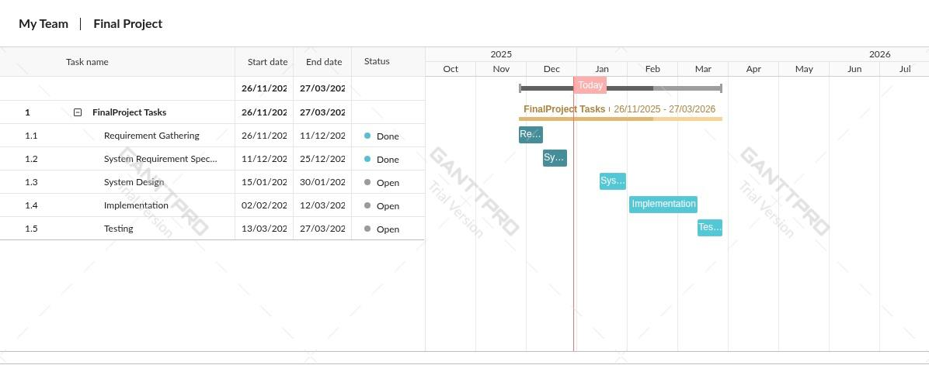
Table 2: Time Schedule

Significance of the Project
The creation of a web-based Student Information Management System of University Non-Boarding Secondary School at Haramaya University has a great significance since it will work towards solving the existing inefficiencies and issues of manual record management. All the stakeholders such as the director, vice director, homeroom teacher and students will find the system beneficial since it will be able to automate the management of student data, as well as enhance the overall efficiency in administration. It will attach to each other functions like student registration, report preparation, and transcript generation to minimize delays and minimize the number of errors. The system will also form the basis of further development, as it will make it possible to manage the increase in the student population and the complexity of the administrative needs that will become more and more extensive.
The most significant advantages of the suggested system are:
- Better administration like registration, report generation and preparation of transcripts.
- More accurate and consistent student records, and fewer errors and lost data.
- Less workload and time can be spent by staff on academic supervision and support of the student, the management and the teachers can be able to attend to it.

- Increased scalability, which offers a foundation to grow in the future and integrate more easily with the university-level reporting and management systems.
- Provide facilities for generating transcripts and academic reports in a timely manner.
- Improve fast searching and retrieval of student records.
- Reduce paperwork and reliance on physical file storage.
- Enhance data accuracy, consistency, and security of student information.

Methodology of the Project

Data Source
Data sources refer to the origins from which information is obtained for analysis, system design, and decision-making. In system development, data sources are typically categorized as primary or secondary. Primary data sources provide firsthand, original information collected directly from stakeholders or users through methods such as interviews, surveys, or observation. Secondary data sources, on the other hand, consist of information already collected and recorded, such as existing documents, reports, registers, and historical records [2]

1.6.2 Data Collection Methods
To gather data that will help develop the Student Information Management System, the techniques that will be used to collect the data depend on the source type:
Primary Data Collection: The desired information was gathered through primary data, so the collected information was based on the direct contact with the members of the school staff to comprehend the existing manual processes and to define the requirements of the system
Interviews: Interviews were carried out with the director, vice director and homeroom teachers in order to get the information regarding the student registration, record management, report generation and administrative issues (Mr. Ahmed Dado (Asst. Prof), personal communication, Dec. 12, 2025).
Observation: Direct observation of the manual operations was conducted to determine inefficiencies in the workflow, bottlenecks and how the student records would be practically handled.
Secondary Data Collection: The secondary information was obtained using the existing school documents to learn about the historical trends, data structure, and reporting conditions:
Document Analysis: The existing student registers, transcripts, report forms, and other administrative records were reviewed, with the purpose of detecting the data format, data flow, and storage patterns.

1.6.3. Fact Finding Techniques
Fact-finding techniques are methods used to gather detailed and accurate information about an existing system to guide the development of a new system. In this project, multiple techniques were applied to understand the current manual student information system and identify user requirements.
Interview: Our group conducted interviews with the director, vice director, and homeroom teachers. These interviews focused on understanding student registration processes, record management, report preparation, and administrative challenges. The feedback collected directly from the staff provided valuable insights into the problems of the existing system and the desired features of the new system.
Observation: Direct observation of the school’s manual operations was performed. Our team examined how student records were stored, how registration and report preparation were carried out, and how teachers and administrators interacted with these records. Observation helped identify workflow inefficiencies, data handling delays, and areas prone to errors.
Document Analysis: Existing school documents, including student registers, transcripts, academic reports, and other administrative records, were analyzed. This helped the team understand historical data patterns, the structure of records, and reporting requirements. Document analysis ensured that the system design would align with the school’s current practices while improving accuracy and accessibility.

1.6.4 Software Development Methodology
The methodology of software development employed in this project is the Agile approach, which is an iterative and incremental technique of delivering software in mini-cycles and that can enable constant feedback and modification. Agile focuses on flexibility, integration, and change responsiveness through creating the system in small workable units instead of one massive release. This enables the development team to clarify requirements, do early testing and incorporate user feedback in the process to enhance both the quality and relevancy of the end product [3].
In this project, We Will be Implementing Agile SDLC to organize the development in the iterative parts with each of the parts being dedicated to particular features, like student registration, attendance management, and reporting modules. The team will discuss the progress after every iteration, test features, and modify future plans, depending on the information they receive about stakeholders. This will make sure that the system conforms to arising needs and functional modules are delivered in pieces and tested all along.

1.6.5 Development Tools
React.js
React.js is a JavaScript library that is applied in the development of user interfaces, and, more specifically, single-page applications via a component-based architecture, which allows users to create efficient renderers and state management [4]. React.js will be employed in this system to design the frontend interfaces, including the login pages, student registration forms, and director and vice director dashboards as well as the student records and report viewing pages.
Node.js
Node.js is a JavaScript runtime environment used on the server which enables the execution of JavaScript on the server, outside the browser, making it scalable and high-performance network applications [5]. The proposed system will create and use Node.js to address the operations of the backend, receive and process client requests on the React frontend, conduct business logic, and handle the user interface-database communication.

Express.js
Express.js is a web application framework, which is lightweight and works with the Node.js that simplifies the development process on server-side by offering routing, middlewares and request-response handling features to it [6]. In this system the Express.js will be utilized in making application programming interfaces (APIs) to do operations like registration of students, updating the student information, retrieving the student reports, as well as handling the authentication and authorization. MongoDB
MongoDB is a document-oriented database management system which is NoSQL and stores data in flexible documents in the form of JSON and this is useful in handling large and dynamic data [7]. MongoDB will be employed in the proposed system to store student personal information, academic records, grade, and reports, which allows student data to be easily updated and accessed directly in a short duration of time.
Visual Studio Code
Visual Studio Code is an IDE that provides integration of code editing, debugging, and version control in a range of programming languages and frameworks [8]. The development team in this project is going to use Visual Studio Code to write, debug, and manage the source code of both the frontend and backend efficiently.
Git
Git is a distributed version management system that enables software program developers to monitor the modification of the source code, teamwork efficiently, and retain numerous versions of a software project [9]. Git can be applied in this system development to oversee the changes in the source code used by the group members, enhance collaboration, monitor the progress in the development process, and avoid the conflict of codes.

1.6.6 Testing Procedures
Testing will be conducted to make sure that the Student Information Management System is in proper operation, secure, and as required by the user. The testing procedure will concentrate on testing the basic system functions, such as user authentication, registering students, managing their attendance, processing academic records, managing their timetable, reporting, and sending messages. The testing plan will comprise of unit testing, integration testing and system testing. Individual system modules are tested by unit testing to ensure the correct output by using valid and invalid inputs. Integration testing is also done to make sure that there is the right interaction of the system components especially the front end, the backend services and the database. System testing is used to analyze the entire system to ensure that the functional and non-functional requirements are addressed such as role based access control, accuracy of data and reliability of the entire system.

1.6.7 Implementation Plan
The implementation plan explains how the proposed system should be ready to work in the operational environment of the school. The system will be implemented in a controlled environment and then fully used as a web-based application. The prelim implementation tasks involve setting up of system components, the database setup and testing system functionality. User training is a decent element of the implementation process. The training will be offered depending on the user roles so that the administrators, teachers, students, and parents are capable of using the system. The system is built bearing in mind the concept of scalability, maintenance to enable future deployment, expansion and integration as institutional requirements change with time.

1.6.8 Scope of the System
The proposed Web-Based Student Information Management System is scope-based and automates and manages the major academic and administrative functions in Haramaya University Non-Boarding Secondary School. The system will be engineered to facilitate student registration, student profile, record attendance, student academic record, generation of reports, and internal communication within the authorized users. It has role-based access control to administrators, teachers, students, and parents so that only those users could access features that are relevant to their roles. The system also helps in quicker information retrieval, accuracy of the data and communication in the school setting. Also, the system is built in a manner that is scalable to accommodate the future growth and implementation in other institutions of a similar nature.
The Proposed system will perform the Following tasks:
- Management of student registration and maintenance of personal and academic records.
- Recording and tracking of student attendance by authorized teachers.
- Storage, viewing, and reporting of academic results and attendance information.

- Role-based access for administrators, teachers, students, and parents.
- Communication between school stakeholders through a messaging feature.
- Web-based, mobile-responsive access through standard web browsers with internet dependency.

1.6.9 Limitation of the System
Although the proposed system has advantages, there are some limitations to the system. The system is computer based thus requiring a reliable internet connection to access and use it. Even though it is mobile-responsive and can be used with mobile browsers, it does not have a specific mobile application in the existing implementation. More so, the system has been initially configured and deployed in the Haramaya University Non-Boarding Secondary School alone and further deployment to other schools was subject to more configuration and customization.

1.6.10 Ethical Consideration of the Project
All ethical concerns were put into consideration during the system development in order to have responsible and secure management of student information. The system also ensures privacy of data by limiting access to sensitive information using role-based authorization allowing users to access only data pertinent to them. Secure authentication controls unauthorized access, data manipulation, and misuse of academic records. The data gathered in interviews and observations was applied with the purpose of academic and system development without breaching the aspects of confidentiality and institutional integrity. These policies make sure that the system runs in a way that does not violate the rights of users, safeguards information about students and that the information systems are ethical in regard to education.

Chapter Two

Description of the Existing System

2.1 Overview of the Existing System
In HU Non-Boarding School, the majority of the academic and administrative functions are performed manually with the use of paper-based records. Important processes like student registration, student attendance, recording of grades, schedule control, communication with parents and generation of report are done by use of printed forms, classroom registers, notice boards and spreadsheet saved on the locations. Though these ways enable the school to operate, they are time-consuming, prone to errors and cannot enable one to quickly access, verify or analyze information easily. Components analysis of the existing practices and related issues is as follows: 1. Student Registration and Enrollment: Registration forms are done on printed forms that are submitted in the admissions office by the parents or guardians. The student’s identifiers are done manually with an inconsistency in the results, without all the information provided and sometimes a duplicate record is taken.
Challenge: Students records cannot be easily accessed or updated easily due to the absence of a central repository, thus this will add more workload to the administration.
- Classroom Attendance: Daily attendance of teachers is taken in physical books. Manual preparation of summaries is done and presented periodically to the administrative office.
Challenge: It is impossible to tell parents about absenteeism immediately or to compare the attendance trends between terms, which postpones the intervention with low attendance students.
- Examinations and Grading: Exams are made, administered and marked. The teachers enter the grades in grade books and the grades are transcribed by the administrators into report cards.
Challenge: The manual process with multi-steps is time-consuming and it is likely to cause transcription errors and thus delay the release of results as well as do not ensure the accuracy of the data.
4.Timetable Management: The schedules of the classes are drawn on paper and put on the notice boards. Any modification is informed either orally to teachers and students. Issue: The use of verbal communication poses a risk of information not reaching all the stakeholders at the right time, bringing about confusion and missed classes.
5Announcements and Communication: Announcements and Communication regarding school events, examination timetables, or other school policy changes are distributed through notice boards, assemblies, or through oral communication. Parents are also normally updated in the form of scheduled meetings or phone calls.
Challenge: The lack of communication channels will lower the effectiveness of disseminating information, and may cause miscommunication or slow delivery of information to the parents and students.
6.Storage of Records and Documents: The storage of important results such as report cards, transcripts, and historical records are kept in physical folders.
Challenge: It is common that searching of archived records can be time consuming. Hard copy can be lost, damaged or lost. Lack of the ability to store records in a secure and centralized digital storage system renders the long-term record management unreliable.

2.2 Players in the Current System
The players in the current system. The current manual system at HU non Boarding School is associated with various important participants, each of whom has a particular role to fulfill and has a certain number of issues related to the utilization of paper-based operations.
School Administrator (Director, Vice Directors): The administrators will oversee admissions, records of students, official reports, liaising with teachers and parents and organize examinations. With the existing manual system, they experience high workload in administration, they experience delays in preparation of reports and they find it difficult to track and retrieve the past records efficiently.
Teachers: Teachers provide classes, record attendance, assess the work of the students, report grades and academic success not only to the administration but also to the parents. They are forced to spend a lot of time conducting administrative procedures through the manual processes and record keeping inconsistencies usually occur. This renders them incapable of analyzing the performance of students fast or coming up with correct reports.
Students: students go to classes, do assignments, adhere to schedules, and monitor the progress of their studies. But in the manual system, they are still not able to get instant information on attendance and grades and have to make do with physical notices or oral communications to get schedules and school news.
Parents / Guardians: Parents or guardians are involved in supporting the learning of their children, following the progress, attending meetings and communicating with the teachers in case of necessity. The manual system not only limits the access to student information in time but also does not allow one to get notifications regarding the absence or performance on time.

2.3 Business Rules
There are business rules that govern the manual processes of HU Non-Boarding School. These regulations will make sure that major operations like student registration, attendance, grading, report distribution as well as communication are done in a uniform and accurate manner. The key business rules of the current system consist of:
BR1: Official Registration Protocol: In order to be admitted, all students should present a registered form with the supporting documents they need. Only physical verification by the school administration is finalized before registration.
BR2: Recording of attendance: The teachers must record the daily attendance in physical registers. Any change made to the attendance record should be in a written form and should be accepted by the administration.
BR3: Grade Submission: The teachers are required to submit the end-of-term grades in hard copy to the administration. The grades are keyed in the report books and subsequently, report cards are prepared.
BR4: Report Dissemination: Distribution of official Semester reports to students is done. Parents must also pick the reports or meet with the meetings to get the reports.
BR5: Timetable Publication: Timetables of classes are done by hand and placed in the notice boards. Any modifications should be spoken out and there is no assurance that all the stakeholders would be updated in time.
BR6: Document Access: Student records are regarded confidential and they can only be accessed under an official administrative request. On Demand information retrieval will be restricted to the office hours.
BR7: Announcement Protocol: the school or class-related announcements are shared through the notice boards, assemblies, or oral communications. Electronic broadcasting system of instant notifications does not exist.
BR8: Channels of communication: The majority of the communication between students, teachers, parents and administrators is done either by meeting face to face or calling each other since it does not have a centralized way of handling queries or feedback.

2.4 Main Functions to the Existing System
The current system at HU non-Boarding School executes some key academic and administrative roles. They are mainly manual functions that are the core of the proposed digital system. The main functions include:
Registration and record management of students.
Registration in HU Non-Boarding School is done by means of collecting printed forms by parents or guardians and this involves student bio data, academic history and other important documents required. A unique identifier is given to each student, and all the records are stored in hard copy. These files are updated manually by the administration when there is a change in the information of students. Such a role also involves the handling of the historical data, including the previous academic performance, academic disciplinary records, and certificates which are kept in physical archives.

Attendance and Class Management
The classroom registers in terms of daily attendance are being written by teachers. Attendance records are summarized and based on the end of the day, this is reported to the administrative office. Classwork, seating, and assignment of subjects are done manually at the beginning of every term and displayed on notice boards. The attendance summaries are also applied to monitor the participation of the students and to make sure that the school rules are being adhered to.
Evaluation and Processing of Results.
The process of examination is manually done since the process of scheduling the examinations to marking the scripts. The scores are entered by teachers in grade books that are later utilized by the administrators to generate report cards and academic transcripts. This role is also related to keeping grade books across several terms and to producing cumulative outcomes on academic considerations. Promotion, scholarships or transfers are done with references to student performance records which are stored in physical files.
Time Table/Subject Schedule.
Schedules are developed by hand and include the subjects, the time of classes, the teachers, and the classroom assignments. All these schedules are put in the notice boards and teachers and students depend on them in carrying out their day to day academic tasks. Any alterations to schedules are either orally conveyed or through announcements during meetings. This role is to ensure that the activities of teaching and learning of the school are arranged and the resources like classrooms and teaching staff are distributed efficiently.
Effective communication and announcements.
The notice boards, the public address system, announcements in classrooms, and verbal communication are used to deliver the school-wide and class-specific announcements. This role involves reporting to students and teachers about the events that are to be organized, timetable of examinations, policies, and other essential announcements. It is also a process of coordination with parents to hold a meeting, consultation and feedback on the progress of students and what is happening in the school.
Reporting and Analytics
Administrative and academic reports preparation is done manually. School staff compiles attendance report, examination results, class performance reports, and other documents relating to compliance. These reports are applied to keep track of the student progress, to plan the academic activities and to make sure that school policies and regulations are adhered to. The record keeping process is done in hard copy files that form the formal accounting of the material that is to be audited and used as a reference.

2.5 Bottlenecks of the Existing System (Using PIECES Framework)

2.5.1 Performance (Response Time)
The current manual system is time-consuming to handle student data, attendance records, examination scores in addition to report preparation. Every activity, including the creation of grades or class schedules, takes a lot of manual effort and time. The use of physical forms and manual calculation slows down the administration processes and makes the system less responsive in general.
2.5.2 Input (Inaccurate/Redundant/Flexible) and Output (Inaccurate)
The current system contains data input errors because the student records, attendance, and grades are manually entered. There is a tendency to have redundant information that includes several copies of registration forms or several entries of the same grade, which enhances the potential of inaccuracies. Report cards and performance summaries which are the output of this may be inaccurate due to errors in transcription and delays in consolidating the data. Also, the system is not flexible enough to accommodate any change in the student information or the schedule of classes.
2.5.3 Security and Controls
The manual system offers a low level of security and control over the student and academic records. Hard copies can be lost or damaged or accessed by unscrupulous people. Automated audit trails and access controls have not been implemented and it is hard to verify the records on its accuracy and integrity. Grading, attendance and reporting mistakes can escape the system until they are checked manually and this minimizes the overall control and accountability in the system.

2.6 Forms and other documents of the existing systems
The current system in Haramaya University Non-Boarding Secondary School is quite intensive as all the student information is managed using paper-based forms and documents. The types are student registration forms, attendance sheets, academic report forms and transcripts. The forms are standardized, that is, the same structure is used in all grades this makes it consistent in recording and reporting of the data. All the processed forms are held in the physical form in the director office, in the filing cabinets. The administrators or teachers have to handwrite the forms again and place them in the files back whenever it requires an update or correction. This will not only burden the administrative functions but also increase the chances of information loss, misplaced information or errors. The process of retrieving the information to make report, verify or make decisions is also time consuming as the personnel has to manually find the needed documents.

2.7 Proposed solution for the new system that addresses problems of the existing system
A Web-Based Student information Management System is recommended to counter the weaknesses of the manual system. The system is also aimed at automating and simplifying every academic and administrative operation of the school to offer efficiency, accuracy, and security.
Some of the major characteristics of the proposed system are:
- Student Registration: Registration of students can be done digitally, hence less paperwork and proper record keeping.
- Attendance Management: It is possible to record and track daily attendance in real-time.
- Academic Record Management: Grades and performance records are added straight into the system thus eliminating errors and duplication of data.
- Report Generation: The transcripts, attendance summaries and academic performance reports can be generated within seconds without editing.
- Messaging Capability: The system will allow communication between teachers, administrators, students, and parents.
- Role-Based Access Control: This ensures privacy of data since users can only have access to information that is related to their roles.
- Mobile Responsiveness: Web browsers can be used to access the system in desktops, laptops, or mobile services. Which Teachers can use their Mobile Phones to record attendances if they have access internet.

2.8 Requirements of the Proposed System

2.6.1 Functional Requirements
Performance Requirements:
The system should be efficient in processing the user requests such as registering students, recording their attendance, submitting grades, and generating reports. Everything must be done swiftly even in cases where more than one user will be using the system.
Process Requirements:
All the key school activities including the registration of students, the tracking of attendance, assignment of courses, scheduling of the school calendar, and the processing of grades should be automated in the system. The process of work should facilitate the communication between the administrators, teachers, students, and parents.
Input-Related Requirements:
The system should be capable of correct and consistent entry of student biodata, attendance tally and examination result and any other academic data. There must be mechanisms of validation that eliminate wrong or incomplete entries.
Output-Related Requirements:
The system must produce proper reports such as attendance reports, academic performance reports, grade sheets. The system should be able to give the outputs to authorized users either via the system portal or downloadable documents.
Storage-Related Requirements:
All the records of students and academics should be stored safely in a centralized database system. The data must be structured in a manner that it is easily retrieved, updated and archived so that they can be preserved and remain intact over a long period.

2.6.2Non-Functional Requirements
Performance:
The system should ensure that response time is quick on all activities such as retrieving data, creation of reports and multiple users at a time. High usage time points, e.g. entry of results or end of term processing, have to be effectively managed. User Interface:
The interface should be friendly, responsive and intuitive to the interface of all types of users (administrators, teachers and students as well as parents). The navigation ought to be easy to use and very little training would be needed.
Security and Access Permissions:
The system has to offer a secure access using the login credentials and role-based permissions. Sensitive data must be encrypted whereby only authorized persons ought to undertake certain functions based on their role.
Backup and Recovery:
The system has to provide frequent backup measures to avoid the loss of data. The recovery mechanisms must enable restoration of data in case system is failed or corrupted or even accidentally deleted in such a way that the data integrity and continuity of operations are not lost.

Chapter Three

System Analysis

Introduction
The development of a Student Information Management System can hardly do without system analysis. It entails reviewing the current manual system in Haramaya University Non-Boarding Secondary School, analysis of the issues with the current system, and a statement of the needs of the intended web-based system. This chapter models the existing and proposed systems based on the selected methodology, such as actors, use cases, diagrams, and conceptual models. Effective analysis will guarantee the new system is effective, safe and will satisfy the requirements of the administrators, teachers, students and parents.

3.1 System Requirement Specifications (SRS)

3.2.1. Use case Modelling
The use case diagram is a system analysis diagram and is used to explain the behavioral description of the system by illustrating the interaction between the system and the user (actors). It aids in coming up with system requirements since it helps to visualize what the system is supposed to do in the eyes of the user and not its implementation [10]. Use case modeling is used in the suggested Web-Based Student Information Management System of the Haramaya University Non-Boarding Secondary School to explicitly specify the interaction between various users of the system. The key participants revealed in interviews are the Administrator, Teacher, Student, and Parent. Every actor has roles and functions that are assigned depending on how much they are allowed to access.

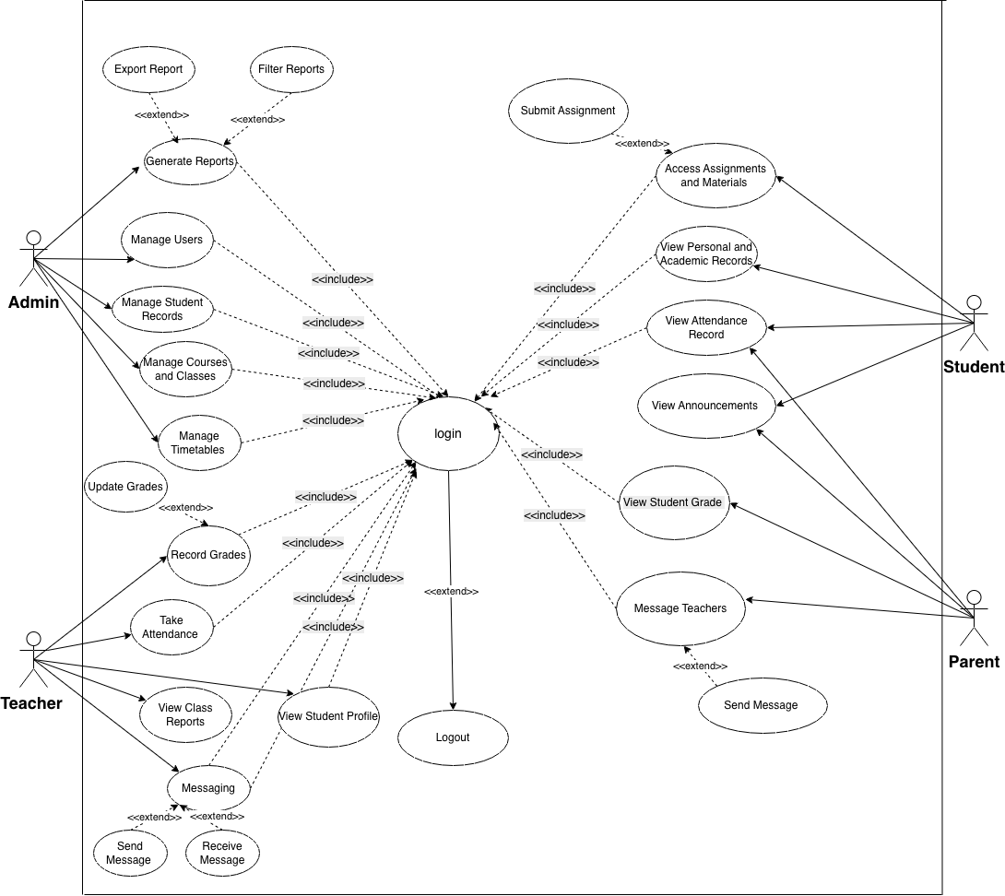
SIMS FOR HU NON-BOARDING SCHOOL

Figure 1: Use case Diagram

3.2.2 Use case documentation/description
ID | Use Case Name | Primary Actors | Brief Description | Preconditions | Postconditions | Alternative Exceptional Actions
UC-01 | Login | Admin, Teacher, Student, Parent | Validates user credentials to grant access to the system. | User must have a registered account in the system. | User is authenticated and granted role-based access. | A1: Invalid credentials; system displays an error message and allows retry.
UC-02 | Logout | Admin, Teacher, Student, Parent | Terminates the active user session securely. | User must be logged in. | User session ends and user is redirected to the login page. | N/A
UC-03 | Manage Users | Admin | Create, update, or delete system user accounts. | Admin must be logged in. | User account data is saved and updated in the database. | A1: Validation error due to missing or incorrect information.
UC-04 | Manage Student Records | Admin | Manage academic and personal student information. | Admin must be logged in. | Student records are updated and stored successfully. | A1: Duplicate student ID or invalid data entered.
UC-05 | Manage Courses & Classes | Admin | Create and manage courses, classes, and teacher assignments. | Admin must be logged in. | Course and class details are updated. | A1: Teacher assignment conflict detected.
UC-06 | Manage Timetables | Admin | Create and update class schedules and timetables. | Admin must be logged in. | Timetables are updated and published. | A1: Scheduling conflict (overlapping rooms or time slots).
UC-07 | Generate Reports | Admin | Generate academic and system activity reports. | Admin must be logged in. | Reports are generated and displayed. | A1: No data found for selected criteria.
UC-08 | Filter Reports | Admin | Filter generated reports based on specific criteria. | Reports must already exist. | Filtered reports are displayed. | A1: Filter criteria returns zero results.
UC-09 | Export Report | Admin | Export reports into downloadable formats (PDF, Excel, etc.). | Report must be generated. | Report file is downloaded successfully. | A1: Selected export format is not supported.
UC-10 | Take Attendance | Teacher | Record student attendance for assigned classes. | Teacher must be assigned to the class. | Attendance data is stored in the system. | A1: Attendance already marked for the selected date.
UC-11 | Record Grades | Teacher | Enter student grades for assessments. | Students must be registered in the system. | Grades are saved in the database. | A1: Entered grade is outside valid range.
UC-12 | Update Grades | Teacher | Modify or correct existing student grades. | Grades must already exist. | Grade records are updated successfully. | A1: Grade record is locked (end of term).
UC-13 | View Class Reports | Teacher | View class performance and attendance summaries. | Reports must be available. | Class reports are displayed. | A1: Insufficient data to generate report.
UC-14 | View Student Profile | Teacher | View individual student academic information. | Student must exist in the system. | Student profile details are displayed. | A1: Student not found in teacher’s assigned class list.
UC-15 | Messaging (Teacher) | Teacher | Communicate with students or parents. | Teacher must be logged in. | Messages are sent or received successfully. | A1: Recipient account is deactivated.
UC-16 | Access Materials | Student | View or download assignments and learning materials. | Materials must be uploaded and available. | Materials are accessed or downloaded. | A1: File link broken or permission denied.
UC-17 | Submit Assignment | Student | Submit completed assignments via file upload. | Assignment submission must be open. | Assignment is submitted and confirmation shown. | A1: File size too large or invalid file format.
UC-18 | View Attendance | Student | View personal attendance history. | Attendance records must exist. | Attendance details are displayed. | N/A
UC-19 | View Student Grade | Student, Parent | View student academic grades and results. | Grades must be recorded. | Grades are displayed to authorized users. | A1: Grades withheld due to administrative restrictions.
UC-20 | View Announcements | Student, Parent | View school-wide announcements. | Announcements must exist. | Announcements are displayed. | N/A
UC-21 | Message Teachers | Parent | Communicate with teachers regarding student progress. | Parent must be linked to a student account. | Message is delivered to the teacher. | A1: Messaging feature disabled by admin.

Table 3: Use Case Description

3.2.3. Sequence diagram
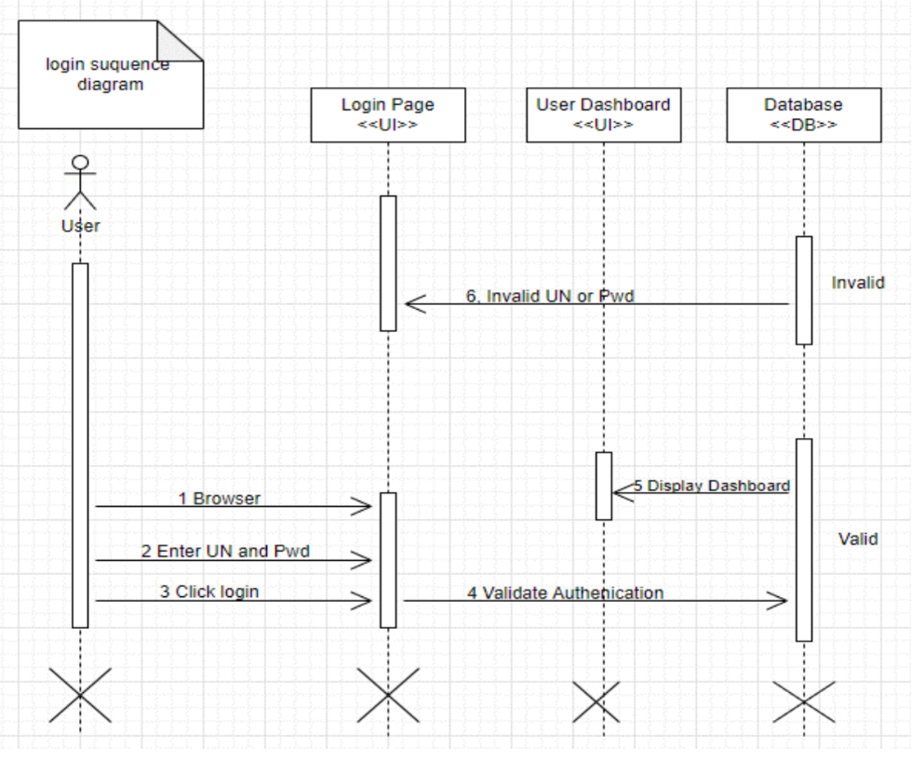
A sequence diagram shows the interaction of objects and system components with one another through time to achieve a given function. It is concerned with a sequence of communication between actors and system elements in a specific situation [10]. The proposed Web-Based Student Information Management System sequence diagrams are employed in order to model interactions flow of major operations which include security login, student registration, recording attendance and generation of reports. These diagrams assist in explaining the communication between the front end, Back end, and database with respect to every process.

Figure 2: Login Sequence Diagram
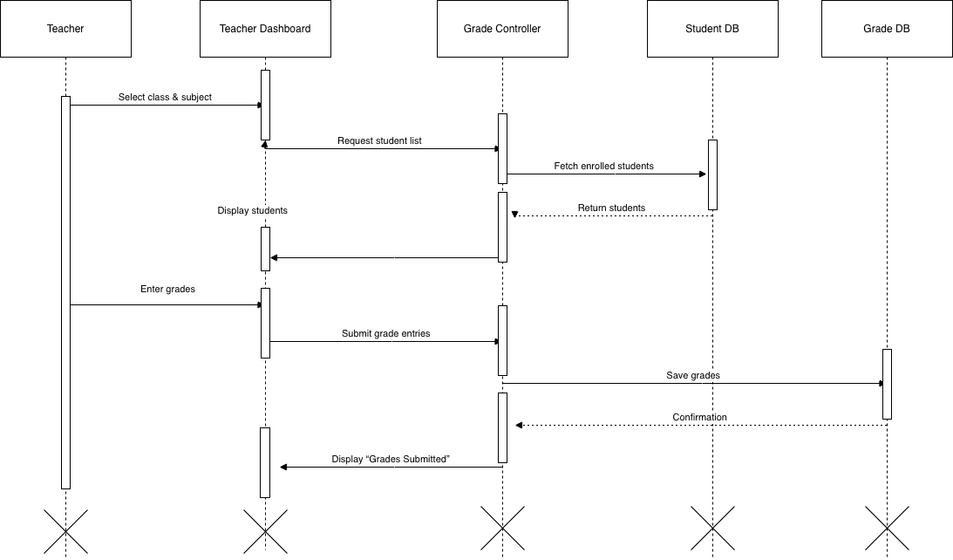

Figure 3: Grade Submission Sequence Diagram

3.2.4. Activity Diagram
Activity diagram is used to depict the flow of activities in a system. It presents the order of activities, decision making and parallel processes of carrying out a task [10]. In this project, the key workflows, including student registration, attendance marking, academic records updating as well as report preparation are modeled using activity diagrams. They give an effective illustration of the workflow in the system, which starts and finishes.

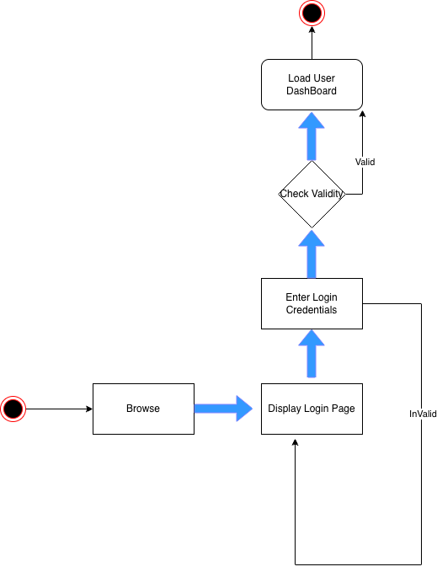
Figure 4: Activity Diagram for Login
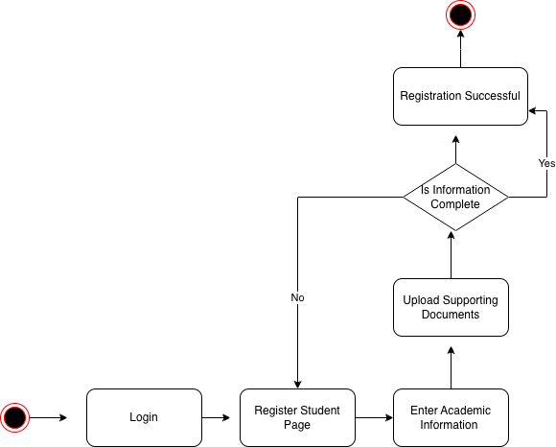
Figure 5: Activity Diagram for Student Registration

3.2.6. User Interface Prototyping
User interface (UI) prototyping is the work of building initial visual designs that show how the users will use an interface of a system. It assists the interested parties to get a clue of layout, navigation, and functionality prior to full development [10]. UI samples in this project are developed around administrator, teacher, student, and parent dashboard. Such prototypes are centered on being usable, clear and role based instead of ultimately visual design.
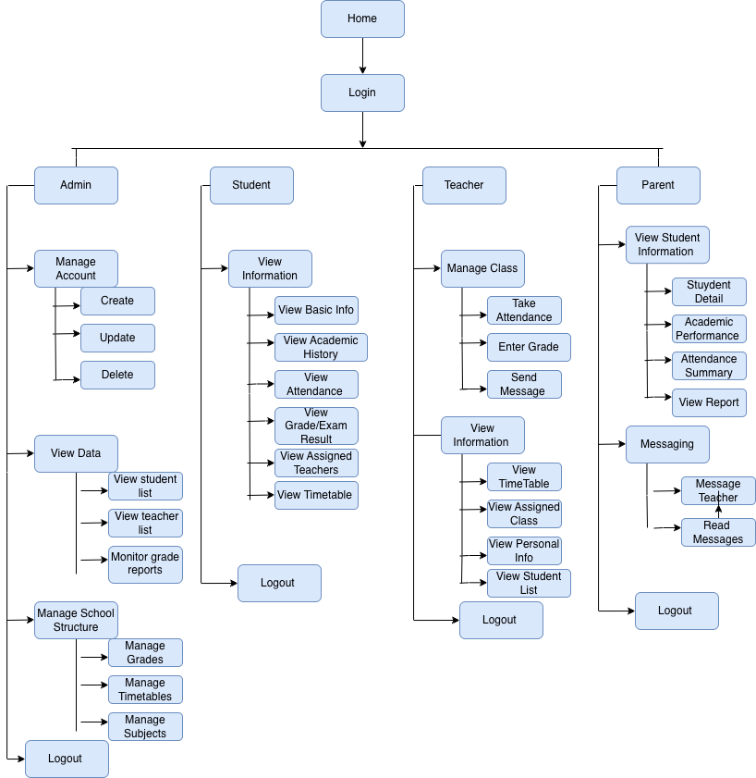
Figure 6: UI Prototyping

3.2.7. Supplementary specifications
Performance Requirements
The system will be able to reply to the requests of the user in reasonable time in a typical usage scenario. The system will be able to accommodate several users of the system at the same time without the performance of the system being greatly compromised. Generation of reports as well as retrieval of student records shall be done effectively.
Access Control Requirements and Security.
All users will be required to log in with a valid user name and a password into the system. The role-based access control will be implemented such that users are only allowed to access authorized functions. The students and parents will only be allowed to view information and not to update official records. Only authorized administrators will have access to administrative functions.
Usability Requirements
The system will have a user friendly and consistent interface. Role-specific navigation menus and dashboards will be simple to use. The system will be accessible to users with low computer literacy.
Availability Requirements and Reliability Requirements
The system will be accessible at the regular school hours of work. It will guarantee data integrity and eliminate the chances of unwanted loss of data. Error handling shall be done properly in order to ensure the system is stable.
Backup and Recovery Requirement.
The system will facilitate frequent data backup in order to avoid loss of student records. The backup information will be saved in a safe place and reinstated on demand. There will be recovery mechanisms just in case the system fails.
Constraints and Assumptions.
The system will be internet-based and reliant on the Internet access. The system will be available using normal web browsers. The system will not have a mobile application but will be mobile responsive. The system will be created to be deployed in future and scaled.

Ethical and Privacy Issues
Data relating to students will remain confidential and inaccessible to the third party. Only the relevant information will be accessed by the users. The system will adhere to Data handling and privacy ethical standards

Chapter Four

System Design

4.1 Introduction
This Chapter discusses about the plan for the HU Non-Boarding High School Student Info System. We're taking what we figured out about what the system needs to do and turning it into an actual design. We’re using UML to map out how everything fits together and how it behaves. Think of it as blueprints showing both the structure and the actions inside the system. The system is built in layers to keep things organized and make sure each part has its own job. This helps the system run better. we’ll go over the whole structure, how the classes work, the state charts, the parts that make it up, database setup, and how the user will see it all. The main thing is to make sure it can handle lots of users without slowing down and that other schools can use it later. This design should make the system easy to keep running smoothly and ready to grow as more people start using it.

4.2 Class Type Architecture

4.2.1 User Interface Layer
The User Interface (UI) lets people talk to the system. It grabs what people input, shows info, and makes getting around easy. It doesn't mess with the important stuff or data. The main thing is that it’s easy to use, open to everyone, and quick. That way, anyone can use the system, no matter what device they're on. Keeping the UI separate from the main system helps keep things neat and makes the system easier to handle [11].
The React is used in the User Interface Layer of Web Based Student Information Management System for HU Non-Boarding High School. js as part of the MERN stack. The system can be accessed using web browser along with responsive interface for Admin, Teacher, Student and Parent. This tier that contains functionalities that are crucial for the system such as managing student personal and academic records, attendance control, grade and exam management, course class and timetable management and reporting and analytics. a Student, Parent portals are available so that when any user(s), after being authenticated, can see academic results, break up, timetable and automatic reports. User Interface Layer interacts with the application layer by RESTful APIs only it doesn't interact directly with the database.

4.2.2 Process (Controller) Layer
Controller or Process Layer controls the flow of control in a system, accepting input from users, ordering related work to be done and coordinating communication between other layers of the system. This tier accepts incoming requests, validates them superficially and figures out what actions should be taken according to the system rules and user permissions. At the most fundamental level it enforces application workflows, takes care of authentication and authorization, and ensures that requests are handled in a coherent way as well as being secure.By separating control logic from presentation and business logic, the controller layer improves system modularity and simplifies maintenance[11]
In the case of the Web Based Student Information Management System for HU Non-Boarding High School, the Controller or Process Layer is implemented with the help of Node.js and Express.js which is part of the popular MERN stack. Coming from the user interface, this layer receives RESTful API requests, steers the back-and-forth of information between the business side and the rest of the system. It’s also in charge of managing user identities using a combination of username and password and laying down rules so that Admins, Teachers, Students and Parents can only access what they’re supposed to. The controller layer is also responsible for sorting out where requests go, checking the validity of the data coming in, handling sessions or tokens and bailing out of errors.

4.2.3 Business (Domain) Layer
The business or domain layer is essentially the heart of the system, when building an application. It encapsulates the main logic, rules and operations that make up the application's domain, and is responsible for modelling real-world entities and their relationships, plus setting the way that data is processed, according to the organization's policies and needs. Coming rushing in after the fact to worry about the user interface or data storage isn’t really its job, it's all about what the system does, and doesn’t care about how it's presented or stored. Well-known for its ability to cut through the clutter and give clarity, consistency and reusability to systems, separating out the business logic into its own layer is definitely a good way to go, especially in large-scale applications. [11]
Concerning the Web Based Student Information Management System for HU Non-Boarding High School, the Business (Domain) Layer forms the core of the system, where the logic for managing student information and academic activities is housed. It includes classes such as Student, Teacher, Parent, Subject, Class, Timetable, Attendance, Academic Record, and User Account, that encapsulate the main elements of the school environment. The rules of managing student records, calculating and storing grades, handling attendance data, and generating reports are here, the way school policies can control what's done within the system. Coming from the standpoint of roles, this layer makes sure that not much can be altered in a student’s academic record unless the person doing it is authorized to do so. The business layer sends its requests to the controller layer and relies on the persistence layer for data storage. It doesn't concern itself with how the data is shown or stored.

4.2.4 Persistent Layer
This layer is responsible for managing data storage and retrieval operations in a system. Coming between the business logic and the database, it conceals the underlying database specifics, allowing for the seamless storage, updating and retrieval of data, without exposing this information to other layers. In a layered system, it’s precisely this Persistence Layer that ensures the consistency, integrity and dependability of the data, and by isolating the persistence concerns from the business logic, also reduces the ‘tightly coupled’ design and gives systems a much more manageable, scalable and flexible nature. [11]
In Web Based Student Information Management System for HU Non-Boarding High School, the Persistence Layer is supported by using MongoDB as part of the MERN stack. This layer is responsible for storing, retrieving and manipulating system data of students, teachers, parents, attendance information marks on the test timetable and user account details etc. Mongoose represents a available Object Data Modeling (ODM) library that is designed to work with data: defining the structure of the schema, handle relationships between these schemas and is used to translate objects in code to their representation back there where your application stores its data (in most cases an MongoDB database). The persistence layer provides a mechanism to carry out data operations that are requested by the business layer in an effective way, while preserving the integrity of the data and assisting performance. Static methods don't allow for easy extendibility or purging of the database.

4.3 Class Modeling
Class Modeling is an insinuation of its static aspect finding its top-level classes, their attributes, operations and relations. In UML, a class diagram is a visual representation of system entities and their interrelations that indicate how data and responsibilities are decomposed in the system domain in which they interact. Attributes specify the properties of each class, operations represent the behaviors associated with classes and relationships like association, aggregation, composition and inheritance explain how classes are linked to one another. Class modeling is the pattern of system implementation, which ensures consistency between system requirements and design, enhances clarity, maintainability and prospects for future extension of the system [11] for suggested Web Based Student Information Management System for HU Non-Boarding High School.

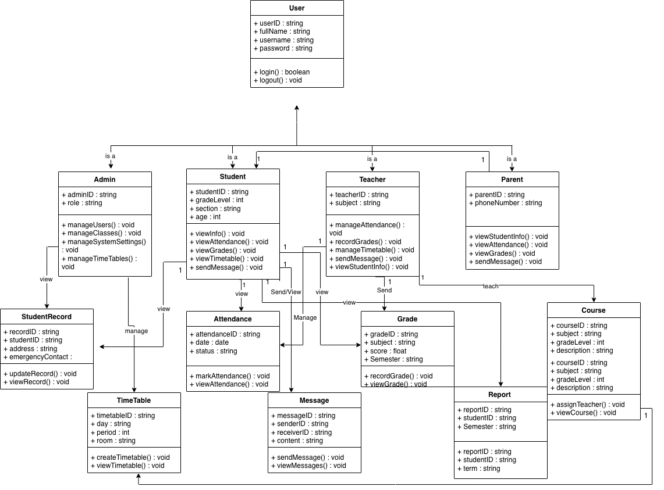
Figure 7:Class Modeling

4.4 State Chart Modeling
State chart modeling is used to express the dynamic behavior of a system by illustrating how an object changes state in response to events over time. A state chart diagram in UML explains the various states of an object and the transitions between those states, as well as the events that cause these transitions [11]. Such modeling is particularly employed in systems in which entities go through a lifecycle, e.g., user accounts, student records, or academic processes. State chart diagrams, by drawing pictorial depictions of state transitions, support visualization of system behavior, validation of logic and diagnosis of potential errors in system operation.
In Web Based Student Information Management System for HU Non-Boarding High School state chart modeling is adopted to describe how important system entities shift from one state to another side periodically during normal operation of the system, increasing clarity and facilitating accurate systems design.

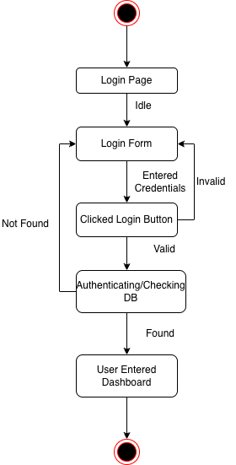

Figure 8: State chart for Login

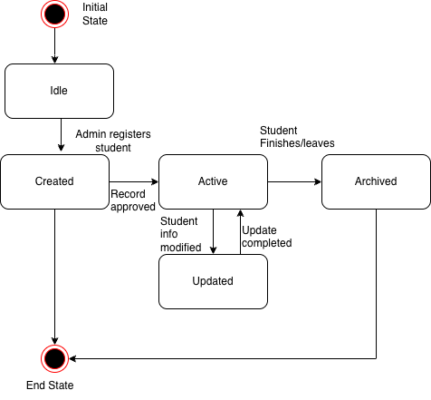

Figure 9:State Chart for Registration and Updating Student Info

4.5 Collaboration Modeling/Diagram
Collaboration diagrams (known as Communication Diagram in UML 2.x) are used to show how objects interact to perform the behavior of a particular use case, or a part of a use case. Along with sequence diagrams, collaboration are used by designers to define and clarify the roles of the objects that perform a particular flow of events of a use case. They are the primary source of information used to determining class responsibilities and interfaces [11].

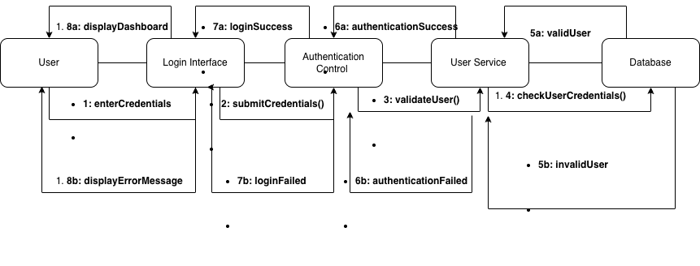
Figure 10: Collaboration Diagram

4.6 Component Diagram
UML Component diagrams are used in modeling the physical aspects of object-oriented systems that are used for visualizing, specifying, and documenting component-based systems and also for constructing executable systems through forward and reverse engineering. Component diagrams are essentially class diagrams that focus on a system's components that often used to model the static implementation view of a system [11].

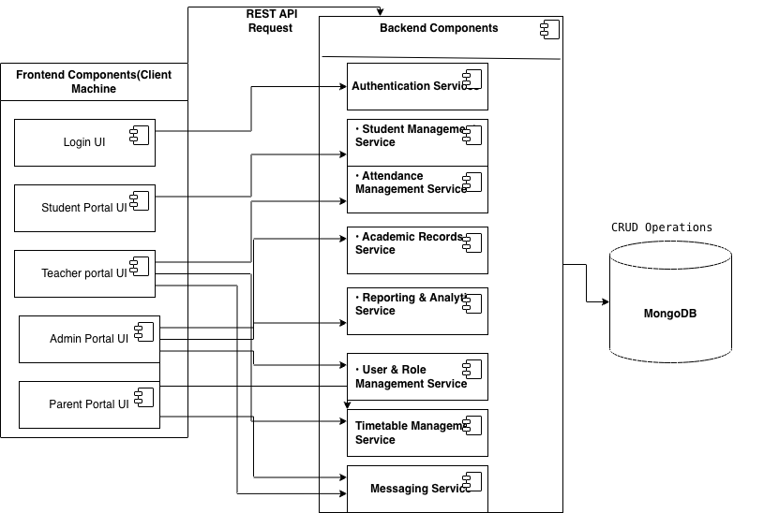
Figure 11: Component Diagram

4.7 Deployment Diagram
A UML deployment diagram is a diagram that shows the configuration of run time processing nodes and the components that live on them. Deployment diagrams is a kind of structure diagram used in modeling the physical aspects of an object-oriented system. They are often be used to model the static deployment view of a system (topology of the hardware) [11].

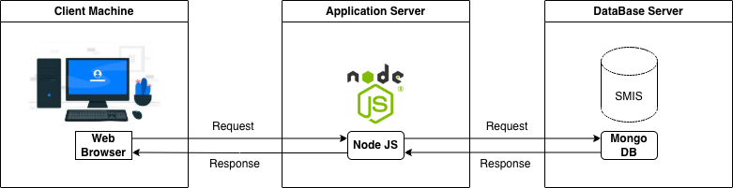

Figure 12: Deployment Diagram

4.8 Persistent Modeling
Persistent database modeling is a form of data modeling in which data structures are designed to persist, as opposed to transient or ephemeral aspects of the system), outside an application’s runtime (they outlive instantiations or sessions). Data persists beyond crashes and forced terminations by users; it lives longer than objects and variables. Techniques include Entity-Relationship Diagrams (ERDs) for relational models, object modeling for Object-Oriented Databases (OODBMS), emphasizing object life-cycles; relationships; and structural integrity featured in system databases like SQL, No-SQL.
User Collection
Field Name | Data Type | Description
userId | ObjectId | Unique identifier for the user
username | String | Login username
password | String | Encrypted password
role | String | User role (Admin, Teacher, Student, Parent)
email | String | User email address
status | String | Active or Inactive
createdAt | Date | Account creation date

Student Collection
Field Name | Data Type | Description
studentId | ObjectId | Unique student identifier
fullName | String | Student full name
grade | String | Grade level (9–12)
section | String | Class section
dateOfBirth | Date | Student date of birth
parentId | ObjectId | Linked parent account
status | String | Active or Archived

Parent Collection
Field Name | Data Type | Description
parentId | ObjectId | Unique parent identifier
fullName | String | Parent full name
phone | String | Contact number
email | String | Parent email
address | String | Residential address
studentId | ObjectId | Linked student

Teacher Collection
Field Name | Data Type | Description
teacherId | ObjectId | Unique teacher identifier
fullName | String | Teacher full name
subject | String | Subject taught
email | String | Teacher email
phone | String | Contact number
status | String | Active or Inactive

Attendance Collection
Field Name | Data Type | Description
attendanceId | ObjectId | Attendance record ID
studentId | ObjectId | Student reference
date | Date | Attendance date
status | String | Present / Absent
recordedBy | ObjectId | Teacher ID

Academic Record Collection
Field Name | Data Type | Description
recordId | ObjectId | Academic record ID
studentId | ObjectId | Student reference
subject | String | Subject name
score | Number | Marks obtained
grade | String | Letter grade
term | String | Semester or term

Timetable Collection
Field Name | Data Type | Description
timetableId | ObjectId | Timetable identifier
grade | String | Grade level
section | String | Class section
subject | String | Subject name
teacherId | ObjectId | Assigned teacher
timeSlot | String | Time and day

Report Collection

Field Name | Data Type | Description
reportId | ObjectId | Report identifier
generatedBy | ObjectId | Admin or system
reportType | String | Attendance / Academic
generatedDate | Date | Date generated
fileFormat | String | PDF or Excel

Messaging Collection

Field Name | Data Type | Description
messageId | ObjectId | Unique identifier for the message
senderId | ObjectId | User ID of the message sender
receiverId | ObjectId | User ID of the message receiver
senderRole | String | Role of sender (Admin, Teacher, Student, Parent)
receiverRole | String | Role of receiver
subject | String | Message subject or title
messageBody | String | Message content
sentAt | Date | Date and time message was sent
status | String | Sent / Read / Archived

Table 4: Persistent Design

4.9 User Interface Design
The Web Based Student Information Management System has a user interface design that aims at providing usability, accessibility and responsiveness so that every user is able to interact with the system effectively. As the system will have multiple roles of users like administrators, teachers, students and parents, the interface will be role-based, where only the relevant features will be shown according to the users permissions. The system adheres to the responsive web design method in order to make sure that it works correctly in desktops, tablets, and mobile devices. React is used to create the user interface and enables reusable components and dynamically engage with the user to enhance user experience and system consistency.

4.9.1 Form Design
The Form design is a very important aspect of the system because it allows the user to key in and modify data correctly. The system has all forms that are made with the intention of simplicity, clarity and validation mechanisms to minimize errors made by the user. The most frequent ones are the forms of logging in, forms of student registration, the forms of entering attendance, forms of submitting grades, forms of creating timetables and the forms of messaging. The input fields, field indicators and validation messages are well identified in each form to assist the user in data input. Role-based access can be used to provide data integrity and security because only authorized persons can access and submit particular forms.

4.9.2 Report Design
Report design aims at making sense of system data to make a decision by providing them in an understandable, summarized, and meaningful way. The system will produce different reports like reports on attendance of students, reports on academic performance, classes, and high-level analytics of the administrators. Reports should be in an easy to read format, they should have appropriate headings, tables and a constant format. The system has a report viewing interface where users can access reports and export them in standard format (PDF or excel) when needed. Report access has user-role control to protect privacy of confidential information.

4.9.3 Dialog and Interface Design
Dialog and user interface design determines how the users will communicate with the system in terms of messages, notifications, and feedback. The dialog messages that are offered by the system include notification on login success or failure, confirmation dialog of important actions, error messages of invalid inputs, and success messages upon data submission. The navigation is maintained simple and uniform on every page through the use of menus and dashboards depending on the user role. The system has messaging features that facilitate communication between administrators, teachers, parents and students. In general, the interface design is consistent, clear, and easy to use to increase system acceptance and usability.

Chapter Five

Implementation and Testing

5.1 Introduction
Implementation and testing are significant steps in system development life cycle because they determine proper development of a system based on its design and functionality. This chapter is concerned with the implementation process and testing plans of the Web Based Student Information Management System of the HU Non-Boarding High School. It maps the arrangement of the system components (based on the chosen technologies) and explains the testing actions that would facilitate the assurance of system functionality, reliability, and performance. Implementation planning and systematic testing should be carried out in order to make sure that the system is able to meet the requirements of the user and that the overall quality of it should be maintained.

5.2 Final Testing of The System
In case of the Web Based Student Information Management System the testing is directed to test the main functionality of the system like authentication and user management, student information, attendance, academic records, timetable, reporting, and messaging. Proper testing enhances the quality of systems because it will be ensured that all the parts and the entire system are functioning well in the conditions as expected.

5.2.1 Unit Testing
Unit testing involves testing part or modules of a system/ system to make sure that every component works as it should. Unit testing in the Web Based Student Information Management System for HU non Boarding School will be used in core modules in the system which include user login, user management, student record processing, attendance management, academic record processing, timetable management, reporting and messaging. The validation of each unit is performed by the means of valid and invalid inputs and checking whether the outputs are as desired. Unit testing can be used to identify errors at a young age and overall quality of the system through ensuring that each small component of the system is correct.

5.2.2 System and Integration Testing
Integration testing takes place to determine whether various modules of a system have the proper functionality after they are put together. This type of testing focuses on the interaction of the front-end and back-end parts, and communication channels between the back-end services and the database. System testing then comes in which overall testing of the system is carried out that all the functional requirements and non-functional requirements are met. In the case of the Web-Based Student Information Management System for HU non-Boarding School, the integration and system testing will be used to ensure that there is a proper data flow, role based access control as well as the concurrent system behavior by all user roles.

5.3 Hardware software acquisitions/specifications
The System takes important hardware and software resources to support its functioning and operation. Hardware requirements include server equipment that will support web app and database applications, as well as client systems (desktop computers, laptops, tablets, or smartphones) with internet access. In software terms, the system is designed to use modern web technologies, such as MongoDB to manage the database and Express.js and Node.js to develop the backend and React to develop the frontend. Additional software (like web browsers, integrated development environments and version control systems) are also essential to development and maintenance. The right choice of hardware and software is central to the attainment of system reliability, scalability, and efficiency in performance.

5.4 User manual preparation
This section explains how various users will use the Web Based SIMS for the HU non-Boarding School by a step wise account of interaction with the system. This system is developed with role-based access in place of which every user can only interrelate with functions that are pertinent to his or her duties.
Administrator Usage
The administrator can log in by first accessing the login page where he/she enters a valid username and password to use the system. When an administrator successfully logs in, he or she is redirected to the admin dashboard where he or she sees system overview information. The administrator can create and manage user accounts of teachers, students and parents, preset roles, permissions and changes system settings, all from the dashboard. With its help, the administrator will be able to enroll new students, maintain records of students, schedule classes, and compile such reports as attendance summaries and academic performance reports. The administrator is also able to check the system messages and also to send messages to other users through the messaging option before leaving the system.
Teacher Usage
A teacher gets into the system with the help of credentials assigned. On logging in, the teacher dashboard appears, which includes assigned classes, and subjects. The teacher is able to keep track of daily attendance by checking a class and marking students present or absent. The teacher is also able to add and amend academic records of students, see the school timetables and create academic or attendance records to classes assigned. Moreover, the teacher is able to send and receive messages to and with the administrators, students and parents through the messaging module. Once the tasks are done, the teacher logs out safely.

Student Usage
To use the system, a student logs on to the system with his or her username and password. Upon successful authentication, the student dashboard appears, and it lists personal and academic information. The student is able to access his or her profile description, attendance history, school performance, and the schedule of classes, all, of course, using the dashboard. The student is also able to read messages posted by teachers or administrators and reply in case it is allowed. The system will be modeled in such a way that students can only see the information but not alter official academic records. The student leaves the system when he or she logs out.
Parent Usage
A parent accesses the system with credentials associated to his/her child. In the parent dashboard, the parent is given access to the academic performance of the student, attendance history, and timetable of the student once the parent logs in. Parents have access to monitoring progress, reviewing reports, and being announced or reported by teachers and the administrators. The messaging tool enables the parents to get in touch with the teachers or the school leaders whenever they have to. Once the parent browses the required information he/she logs out of the system.
General System Navigation
The system has a user friendly interface that has a uniform and responsive interface that all users communicate with. Navigation menus and dashboards are role specific and hence they are easy and secure. The typical actions of the system that include login, logout, reading information and sending a message have standardized interaction patterns to ensure that there is less confusion to the user and the system becomes easier to use.

5.5 Training
Training is a critical practice that will make the users know how to use and operate the system effectively and appropriately. In the case of Our SIMS System, training will be conducted based on the user roles to deal with various duties and interaction with systems. Administrators are also given a comprehensive instruction on how to manage the user accounts, keep the student records, arrange the timetable, and also create the system reports and a check on the general running of the system. Teachers will be trained about how to enter and update attendance, academic outcomes, access class schedules, and communicate with students and parents using the messaging option. Students and parents are instructed in using the system to access dashboards and get in touch with school staff to access information about academic performance and attendance and exchange messages. Adequate training will reduce the number of user errors, user confidence will be promoted and effective system adoption in the school environment will be facilitated.

5.6 Installation Process
The installation process outlines the steps required to prepare the system for operational use in a real environment. For the Web Based Student Information Management System, installation involves setting up the necessary software and hardware infrastructure to support system functionality. This includes configuring a web server environment, setting up backend services using Node.js and Express, and preparing the MongoDB database for data storage. The frontend application is configured to allow access through standard web browsers. Basic security configurations, such as access control and system settings, are also established during installation. A well-defined installation process helps ensure system stability, security, and readiness for use.

5.7 Start-Up Strategy
The start-up strategy explains how the system would be rolled out to the users in a systematic and managed way. For Web Based Student Information Management System for HU non-boarding school, the implementation will be done in stages to ensure a smooth adoption process and reduce possible difficulties. At first, administrators would start manipulating the system and create user accounts, student records, schedules, and system preferences. Once the administrators are prepared, the teachers would be given access to handle attendance and academic records. Lastly, the students and parents would also gain access to access academic information, attendance records, schedules, and use the messaging feature. The user feedback would be gathered during the initial usage period to identify which areas need improvement to facilitate the system improvements in the future. This step by step start-up plan is useful in maintaining stability and usefulness of the system in the school setting.

Chapter Six

Conclusion and Recommendation

6.1 Conclusion
The proposed Web-Based Student Information Management System (SIMS) of Haramaya University Non-Boarding Secondary School will deal with the issues that are found in the current manual system. The school is currently using paper-based processes to register students, keep academic records, manage attendance, prepare reports and communicated and this is the reason why the school loses data, slows down and the administration is overworked.
A web-based solution, planned through careful system analysis, modeling and design, will do:
- Manage student records digitally, in a centralized and organized form.
- Automate major functions of the institution including registration, attendance, updating of academic records, and generating of reports.
- Offer role-based dashboards to administrators, teachers, students and parents so that only the relevant information can be accessed by the user.
- Integrate a messaging platform to be used in communication.
The documentation and design proves that a web-based system could contribute to efficiency, error reduction, as well as access to information in time, be mobile-responsive, and scalable to use in the future.
All in all, the project offers an analyzed, feasible, and applicable solution to modernize the information management of students in the school.

6.2 Recommendations
According to the analysis and system design, the following recommendations can be proposed on the basis of further development and implementation:
- Planning System Implementation.
- Implement the system in phases with proper software and hardware requirement. Delegating the maintenance and deployment to trained personnel.

- Future Enhancements: Create a mobile solution to access offline and facilitate the use of students or teachers. Enhance reporting and analytics capabilities to track the student performance trend. User Training and Support
- Make training sessions to the administrators, teachers, students and parents to acclimatize them to the system.
- Include extensive user guides and instructions on-line.
- Data Security and Privacy: Implement access control based on their roles to ensure the privacy of student data. Create safe backup and recovery procedures to curb possible loss of data.
- Continuous Improvement
- Gather user responses post implementation to promote functionality and usability.
The system design should be maintained with updated web technologies to be able to be sustained over the long term.
Future versions of the project could include cloud deployment, multi-user concurrency handling, alert Mechanisms, AI-driven analytics for forecasting student performance and Third-party integrations like google workspace etc. This project is also recommended for students and researchers who want to strengthen their skills in system analysis, requirement modeling, and structured documentation. It is particularly useful for academic projects where understanding system workflows, data relationships, and user interactions is more important than full implementation.

References
[1] K. C. Laudon and J. P. Laudon, Management Information Systems: Managing the Digital Firm, 15th ed. Boston, MA, USA: Pearson Education, 2018.
[2] “Sources of Data Collection | Primary and Secondary Sources,” GeeksforGeeks, 2025. [Online]. Available: https://www.geeksforgeeks.org/sources-of-data-collection/
[3] S. Robinson, K. Brush, and V. Silverthorne, “Agile Software Development,” TechTarget, Oct. 18, 2024. [Online]. Available: https://www.techtarget.com/searchsoftwarequality/definition/agile-software-development
[4] Meta Platforms, “React Documentation,” 2024. [Online]. Available: https://react.dev
[5] OpenJS Foundation, “Node.js Documentation,” 2024. [Online]. Available: https://nodejs.org/en/docs
[6] OpenJS Foundation, “Express.js Documentation,” 2024. [Online]. Available: https://expressjs.com
[7] MongoDB Inc., “MongoDB Manual,” 2024. [Online]. Available: https://www.mongodb.com/docs
[8] Microsoft, “Visual Studio Code Documentation,” 2024. [Online]. Available: https://code.visualstudio.com/docs
[9] Git SCM, “Git Documentation,” 2024. [Online]. Available: https://git- scm.com/doc
[10] K. E. Kendall and J. E. Kendall, Systems Analysis and Design, 9th ed. Boston, MA, USA: Pearson, 2014.
[11] IEEE Std 830-1998, IEEE Recommended Practice for Software Requirements Specifications. New York, NY, USA: IEEE, 1998.

